**HTML Name:** landing

1. Please change benefits to this: **- DONE**
   1. Guaranteed Income from end of 1st Policy Month@
   2. Increasing Guaranteed Income
   3. Get Loyalty benefits on timely premium payments.
   4. Life Cover that continues even if you miss 1 premium.
   5. Enhanced Benefits for females
   6. Get Annual Income on Your special day

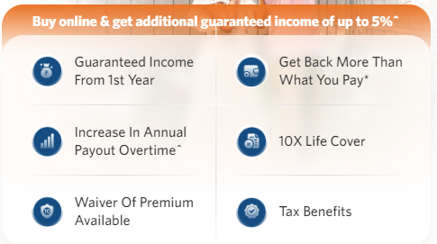

Please add below disclaimer in the footer section: **- DONE**

^*Get additional Base Income of 2% for 6 Pay, 3% for 8 Pay and 5% for 10 Pay on buying through online mode*.

@end of 1st policy month, if immediate income option is selected with monthly income payout frequency

1. “Change “Get Income for” text in **How Plan works part to**: Get Benefits Over**- DONE**  
   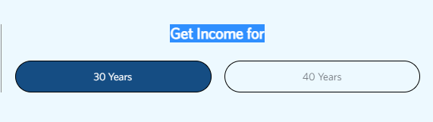
2. How will we show cashback here for deferred income option? - DONE  
   A picture containing text, screenshot, number, font

   Description automatically generated  
   Add a disclaimer for Income benefit* as follows, below the table after maturity benefit disclaimer:  
   *Income Benefit includes Base Income, Loyalty Income & Cashbacks, if any
3. Remove maturity bar from below graph and add it in below format as follows: - PENDING

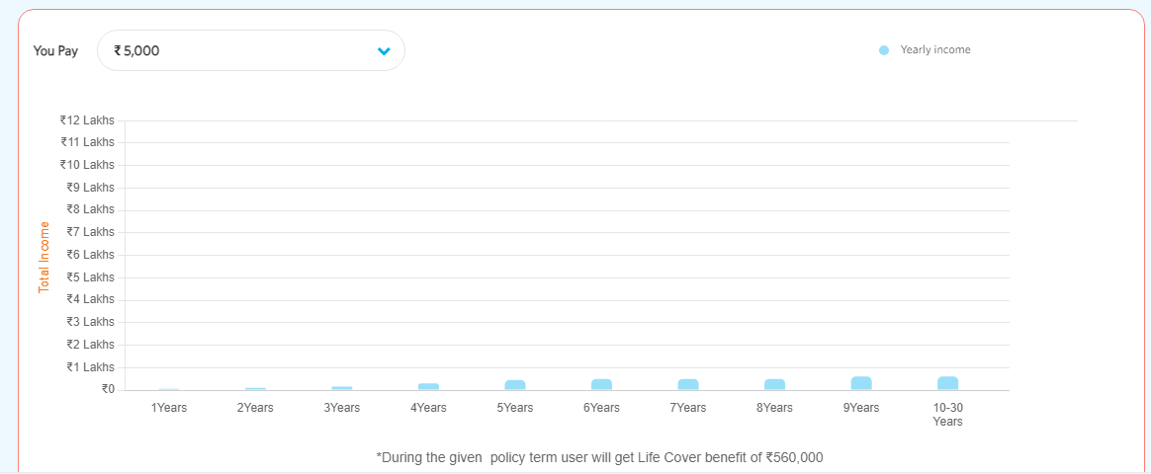

**+**

**Get Maturity Benefit of Rs. 30 Lakh** (in the end of policy term)

1. Replace the content in What are the benefits of buying Guarantee of Life Dreams Plan with below: **- DONE**
   1. **Choice of 3 Income Options**Start receiving Income from as early as end of 1st policy month or defer your Income depending on your needs.
   2. **Guaranteed Long Term Income**Ensure a Guaranteed source of Income for as long as 30 or 40 years, as per your choice basis Income option chosen.
   3. **Life Insurance Cover**Secure your family’s future with a Life Cover throughout the policy term
   4. **Benefits of long-term Savings.**Get rewarded for paying your premiums on time with our Loyalty benefits
   5. **Protection even if you miss one premium.**Stay covered even if you miss a premium through Life Cover Continuance Benefit, at no additional cost.
   6. **Tax benefits**Available on the premiums paid and benefits received as per prevailing tax laws  
      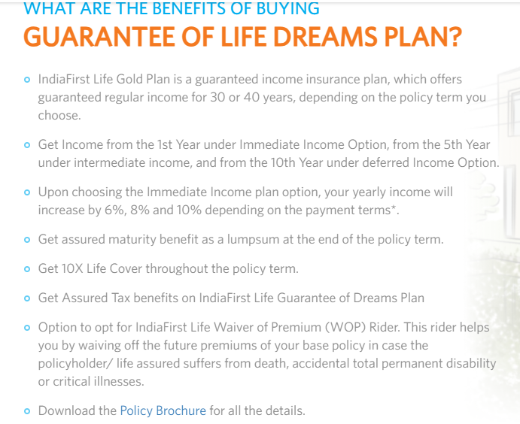

***Change the text under: THREE PLAN OPTIONS THAT CAN HELP YOU MEET YOUR INCOME GOALS* - DONE**

**Deferred Income Option:**

**Receive a regular income from the end of the 10th year of the policy with the benefit of life cover**

* + 1. **Pay premiums for a fixed period - 6, 8 or 10 years.**
    2. **Receive a regular income in yearly, half-yearly, quarterly, or monthly frequency till the end of the chosen policy term, i.e., for 30 or 40 years.**
    3. **Loyalty income benefits grow your income further when you pay all premiums on time.**
    4. **Get a discount if you pay the premium a month prior to the premium due date.**
    5. **Receive the base income and Loyalty income till the end of the policy term as survival benefit, provided all premiums have been paid.**
    6. **Get additional Cashbacks as survival benefit, i.e., 2 installments of lumpsum benefit, both equal to 50% of annualized premium, payable at the end of the 3rd policy year and at the end of PPT.**
    7. **Receive the Sum Assured on Maturity as maturity benefit at the end of the policy term, provided all premiums have been paid.**
    8. **Stay covered even if you miss a premium payment with the complementary Life Cover Continuance Benefit.**
    9. **The plan offers Waiver of Premium (WOP) Rider in which future premiums are waived off in case the policyholder/ life assured suffers from death, accidental total permanent disability, or critical illnesses.**

**Intermediate Income Option:**

**Receive a regular income from the end of the 5th year of the policy with the benefit of life cover.**

1. **Pay premiums for a fixed period - 6, 8 or 10 years.**
2. **Receive a regular income in yearly, half-yearly, quarterly, or monthly frequency till the end of the chosen policy term, i.e., for 30 or 40 years.**
3. **Loyalty income benefits grow your income further when you pay all premiums on time.**
4. **Get a discount if you pay the premium a month prior to the premium due date.**
5. **Receive the base income and Loyalty income till the end of the policy term as survival benefit, provided all premiums have been paid.**
6. **Receive the Sum Assured on Maturity as maturity benefit at the end of the policy term, provided all premiums have been paid.**
7. **Stay covered even if you miss a premium payment with the complementary Life Cover Continuance Benefit.**
8. **The plan offers Waiver of Premium (WOP) Rider in which future premiums are waived off in case the policyholder/ life assured suffers from death, accidental total permanent disability or critical illnesses.**

**Immediate Income Option:**

**Receive a regular income from the end of the 1st year of the policy with the benefit of life cover**

1. **Pay premiums for a fixed period - 6, 8 or 10 years.**
2. **Receive a regular income in yearly, half-yearly, quarterly, or monthly frequency till the end of the chosen policy term, i.e., for 30 or 40 years.**
3. **Loyalty income benefits grow your income further when you pay all premiums on time.**
4. **Get a discount if you pay the premium a month prior to the premium due date.**
5. **Receive the base income and Loyalty income till the end of the policy term as survival benefit, provided all premiums have been paid.**
6. **Receive the Sum Assured on Maturity as maturity benefit at the end of the policy term, provided all premiums have been paid.**
7. **Stay covered even if you miss a premium payment with the complementary Life Cover Continuance Benefit.**
8. **The plan offers Waiver of Premium (WOP) Rider in which future premiums are waived off in case the policyholder/ life assured suffers from death, accidental total permanent disability or critical illnesses.**
9. **Change the heading “Key Features” to “Additional Benefits”: - DONE**
   1. **Save the Date Feature**

**Choose to receive your annual income on a specific date special to you or your loved ones.**

* 1. **Discount on Advance Premium**

**Get a discount by paying your renewal premium at least 1 month in advance.**

* 1. **Life Cover Continuance Benefit**

**Stay protected with a Life Cover for 1 year even if you miss paying a premium.**

* 1. **Enhanced Benefit for Females**

**Female lives are eligible to receive higher income benefit.**

1. **Change below text in how to buy online section to“savings plan is one of the best income plans…” - DONE** 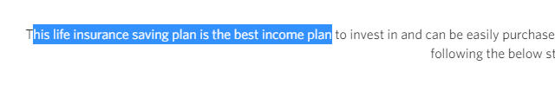
2. **Replace the word “Term” with “Premium Payment Term” - DONE  
   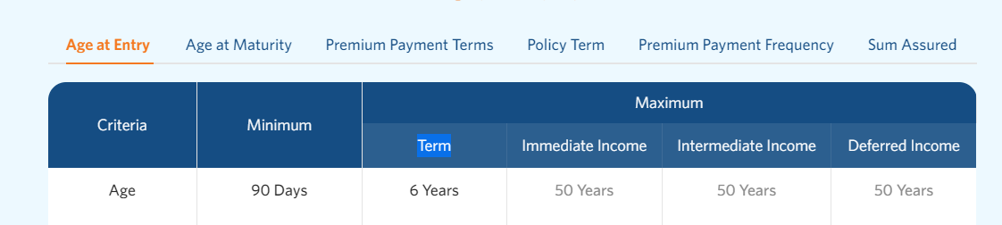**

**Remove minimum and maximum column and keep: 30 years / 40 years as one text similar to “Premium Payment Terms”: - DONE  
**

**Change the FAQs as per below: - DONE**

1. **What is a guaranteed income plan?**

A guaranteed income plan is an assured income plan that offers life insurance plus saving. This is a non-linked, non-participating, Individual Saving, limited premium paying, Life Insurance plan, it provides you with guaranteed long term income for upt to 30 or 40 years.

1. **What is the maturity benefit in guaranteed income plan?**

Maturity benefit is the lumpsum amount or Sum Assured on Maturity that you receive on surviving till the end of the policy term.

Sum assured on Maturity is X% of sum of all Annualized Premium paid under the policy

where X% is 100% for Immediate and Intermediate Income options and 150% for Deferred Income option.

1. **What is the survival benefit in guaranteed income plan?**

Survival benefit is the amount you receive during the course of the policy term. This guaranteed income plan offers base income, i.e., a percentage of the annualized premium you will be eligible for at the start of the income period as per your chosen option. The base income is subsequently enhanced with Loyalty income, an additional income which becomes payable if all premiums are paid on time. You will also receive 2 cashbacks under Deferred Income Option.

1. **Should you invest in guaranteed income plans?**

Yes. A guaranteed income plan is the one of the best investment plan to help you achieve your goals or fulfil other responsibilities. It is a limited pay plan that offers guaranteed long term income. It offers you an assured income with life cover to make your family financially secure for 30 to 40 years.

1. **What is monthly payout mode in Death Benefit?**

The monthly payout mode in death benefit is to provide financial security to the nominee, post the policyholder’s demise. The death benefit or sum assured is paid out as monthly instalments to the nominee instead of as a lumpsum amount.

1. **What is a guaranteed income plan?**

A guaranteed income plan is a regular income plan that invests in low risk, debt instruments to give you an assured, fixed guaranteed income.

1. **How an income plan works?**

In an income plan, the policyholder pays the premium for the premium paying term, in lieu of which they receive a regular, fixed amount in the chosen frequency, all through the policy tenure.

1. **How safe are Guaranteed income plans?**

Guaranteed income plans invest in low-risk funds. This makes them a safe income plan.

1. **How to calculate the guaranteed returns on my total investment?**

Here's how simply you can calculate it.

Total income + Total Maturity + Loyalty Cashback (for deferred income option only)

÷

Total premiums paid.

1. **Is there any monthly income insurance plan?**

There are many income insurance plans that offer Monthly Income. Guarantee Of Life Dreams Plan by IndiaFirst Life is one of the best guaranteed income plans currently available.

1. **Should you invest in a Guaranteed income plans?**

Guaranteed income plans are safe as they are low-risk and hold investments in stocks that pay regular dividends. So, you can be assured that your capital is safe, while planning for long term goals.

1. **What does Guraranteed income mean in life insurance plan?**

A Guaranteed income plan in life insurance gives you the benefit of life insurance plus saving. You pay your Premiums during the premium payment term, in return, the plan pays you back in monthly instalments throughout the policy tenure, rather than as a lumpsum at the end of the policy term. This assures you of a fixed income & adequate life cover for a good many year.

1. **HTML Name: landingShow**
2. **Replace Get Income for with: Get Benefits over - DONE A picture containing text, screenshot, font, line

   Description automatically generated**
3. **Add “Back" CTA here, remove it from top - DONE**



1. **Remove the word Loyalty from below:**

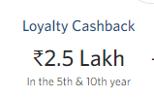 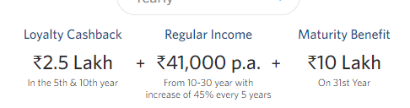

**For Immediate Income option the text will be as follows** – Screenshot shard to Brynal

Yearly Income Yearly Income

Base Income Regular Income Maturity Benefit

Rs. 19,444 p.a. + Rs. 41,000 p.a. + 10 L

From 1-9 year with 10% increase every year from 10-30 year on 31st Year

**For intermediate option the text will be as follows** - Screenshot shard to Brynal

Yearly Income Yearly Income

Base Income Regular Income Maturity Benefit

Rs. 19,444 p.a. + Rs. 41,000 p.a. + 10 L

From 5-9 year with 15% increase every year from 10-30 year on 31st Year

1. Hopefully the benefit amounts with and without discount are the total benefit amounts (Income + Maturity + Cashback (if any)). Correct typos (“Get” instead of Gert) **- DONE  
   A screenshot of a phone

   Description automatically generated with low confidence  
     
     
   HTML Name: Inner & Inner One: Please remove I want to invest and self, spouse option from third page completely. Follow below screenshot for more details.**
2. Add **Back** Button beside - DONE
3. **A picture containing text, screenshot, font, number

   Description automatically generated**- DONE **A screenshot of a computer

   Description automatically generated with medium confidence**